**DESIGN DOCUMENT**

OBSTACLE DETECTED

LOCATION IS GOT FROM THE GPS

START

**17/pcsa/509**

Introduction

The Global Positioning System (GPS) is a U.S. Space based radio navigation system that provides reliable positioning, navigation, and timing services to civilian users on a continuous worldwide basis. GPS based blind man device with user input interfacing (voice based) intellectually finds the current location and gives the alert to the blind man if it was his destination area. This device is designed to provide a voice based announcement for the user, I . e, the user gets the voice which pronounces his destination location as and when he is about to reach the destination. Here instead of an alarm sound the blind man can directly hear the location recorded by the user itself.

Architecture design

The system designed consists of a GPS receiver and a voice circuit which is interfaced to the microcontroller. The microcontroller is programmed in such a way that depending on the satellite information of location the predefined location name will be announced.

No

Yes

STOP

LATITUDE AND LONGTITUDE IS DISPLAYED

SPEAKER GIVES AUDIO SIGNAL

SPEAKER GIVES THE CURRENT LOCATION

Activity diagram

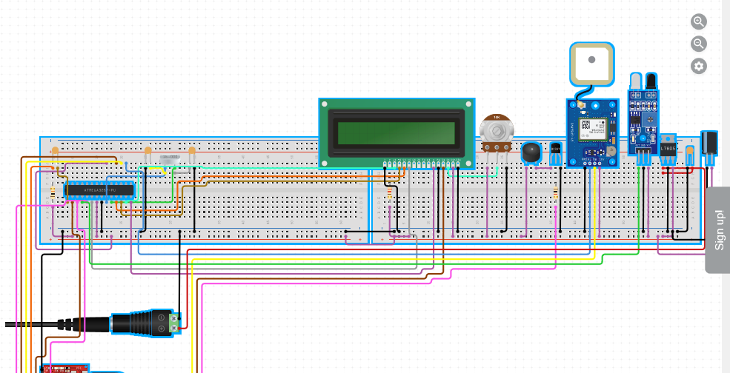

References

<https://www.elprocus.com/gps-based-voice-alert-system-for-blind-people/>

[https://www.ijser.org/viewPaperDetail.aspx?JAN1109](https://www.ijser.org/viewpaperdetail.aspx?jan1109)

<http://citeseerx.ist.psu.edu/viewdoc/summary?doi=10.1.1.301.9425>

[http://www.ijsrd.com/articles/IJSRDV1I9056.pdf](http://www.ijsrd.com/articles/ijsrdv1i9056.pdf)

<https://core.ac.uk/display/22637395>

<https://www.visiplex.com/voice-alert-system/>